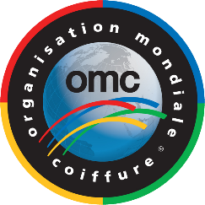

OMC MEMBERSHIP APPLICATION
Please fill out the application form and send it to info@omchairworld.com

- OMC Multiple Membership
- OMC Associated Membership in existing member countries
- Individual Associated Membership in none OMC member countries
- Aesthetics & Nails (if the organization is not part of a member organization)

All new member country organizations can apply for membership at the OMC head office, as long as they meet the OMC membership criteria and show documents proving that they represent the Sector concerned (re. detailed information about membership with OMC).

Country .................................................................................................

Name of Organization ................................................................................................................................
Name of Organization President ................................................................................................................

Mailing Address .........................................................................................................................................

Phone ................................................ Fax ............................................... email ..........................................

Website address ..........................................................................................................................................

Organization's existence date .....................................................................................................................
Organization's activity within its country

- Education  Competitions  Seminars  Others

Contact Person ............................................................................................................................................
Communication Language within OMC (please check):

- English  French  German  Russian  Spanish

Documents to be enclosed (in English):
- Bylaws of your organization
- Number of members
- Document showing that you represent the Hairdressing Aesthetics and/or Nails Sector/s

Admission and Membership Fees
The amount of membership fees varies from a minimum to a maximum cap for each country. The amount is based on the population, number of salons and GNP of each individual country. Each member organization, besides the annual dues, will also pay the Zone Educational Operational Fee. Once the membership is approved, the applicant has 30 days to pay the current membership dues.

Date/Place: .................................................................................................................................................
Stamp of Organization and President's Signature

....................................................................................................................................................................
1/1

