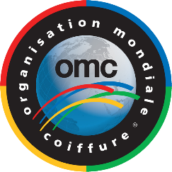

OMC MEMBERSHIP APPLICATION
Please fill out the application form and send it to info@omchairworld.com

- OMC Multiple Membership

All new member country organizations can apply for membership at the OMC head office as long as they meet the OMC membership criteria and show documents proving that they represent the Sector concerned (re. detailed information about membership with OMC).

Country .................................................................................................

Name of Organization ................................................................................................................................

Name of Organization President ................................................................................................................

MailingAddress.........................................................................Phone...............................................

Website address ..........................................................................................................................................

Organization's existence date .....................................................................................................................

Organization's activity within its country

- Education  Competitions  Seminars

Communication Language within OMC (please check):

- English  French  German  Russian  Spanish

Documents to be enclosed (in English):
- Bylaws of your organization
- Number of members

Admission and Membership Fees
The amount of membership fees varies from a minimum to a maximum cap for each country.

Date/Place: .................................................................................................................................................
Organization and President's Signature

....................................................................................................................................................................
1/1

